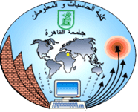Cairo University  
Faculty of Computers and Information



**CS251**

**Software Engineering I**

Online Educational game

Software Design

Team Names

Month & Year

Contents

Instructions [To be removed] 3

Team 3

Document Purpose and Audience 3

System Models 3

I. Class diagrams 4

Important Algorithm 5

II. Sequence diagrams 6-8

Class - Sequence Usage Table 9

# Team

|  |  |  |  |
| --- | --- | --- | --- |
| **ID** | **Name** | **Email** | **Mobile** |
| 20120055 | Ahmed Mohamed el-naggar | Negro.mido74@gmail.com |  |
| 20120314 | Mohamed sayed el-naggar | Mohamedsayedfci8@gmail.com |  |
| 20120086 | Eslam hassan ali | Eslamhassan7472@gmail.com |  |
| 20120267 | Amr kamal el-diin | Amr kamal Eldeen hassan |  |

# Document Purpose and Audience

* This document illustrates the design of the project
* This design used in the implementation
* This design facilitates the implementation of the project

# System Models

## I. Class diagrams

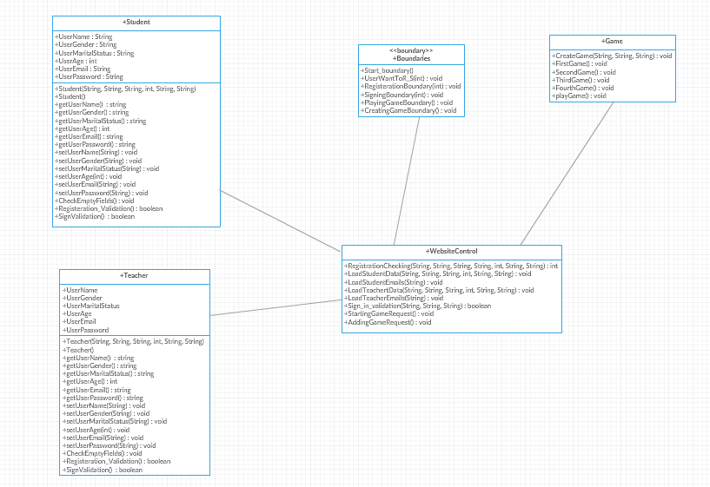

| **Class ID** | **Class Name** | **Description & Responsibility** |
| --- | --- | --- |
| 1 | boumdry | Represent El interaction between user and system |
| 2 | WebsiteControl | mange checking and validation of the user make |
| 3 | User(student and Teacher) | Save data about student and teacher |
| 5 | Game | Implement the game rules |

## 

## II. Sequence diagrams

**1)**

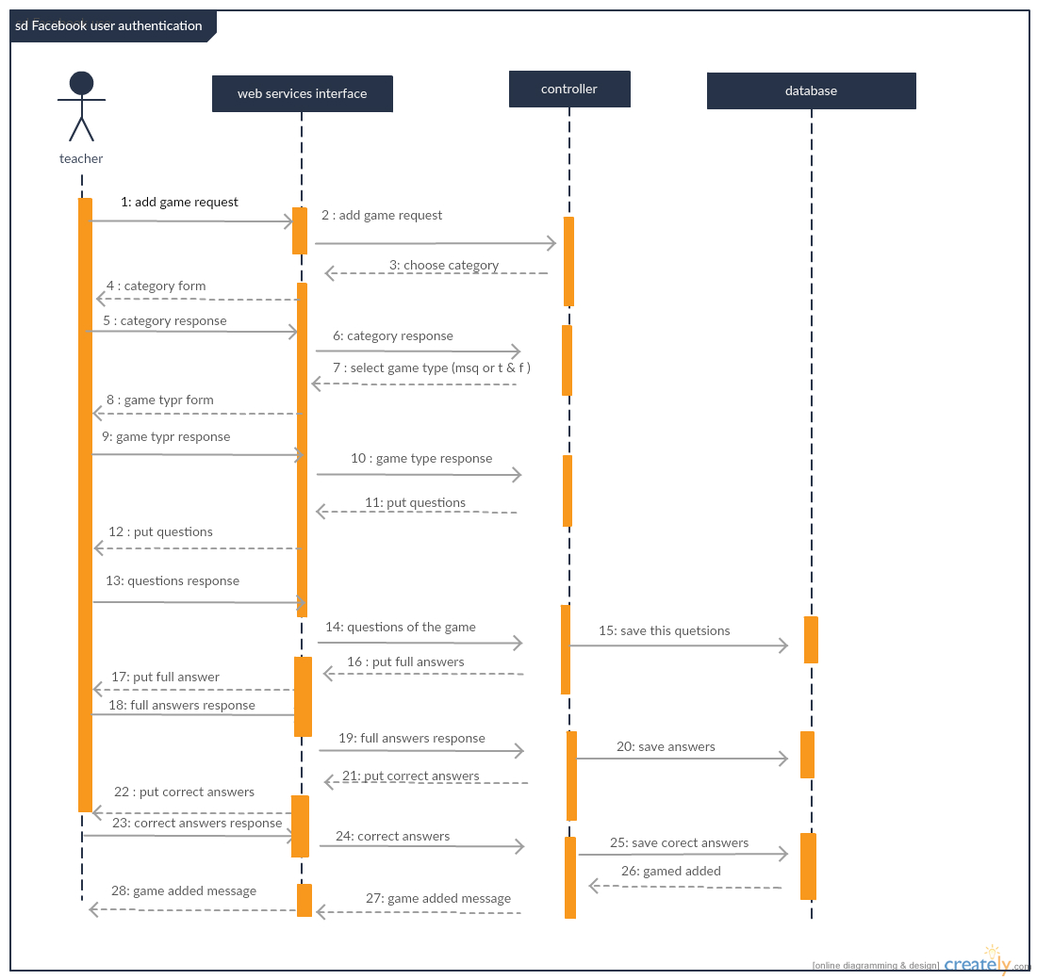

**2)**

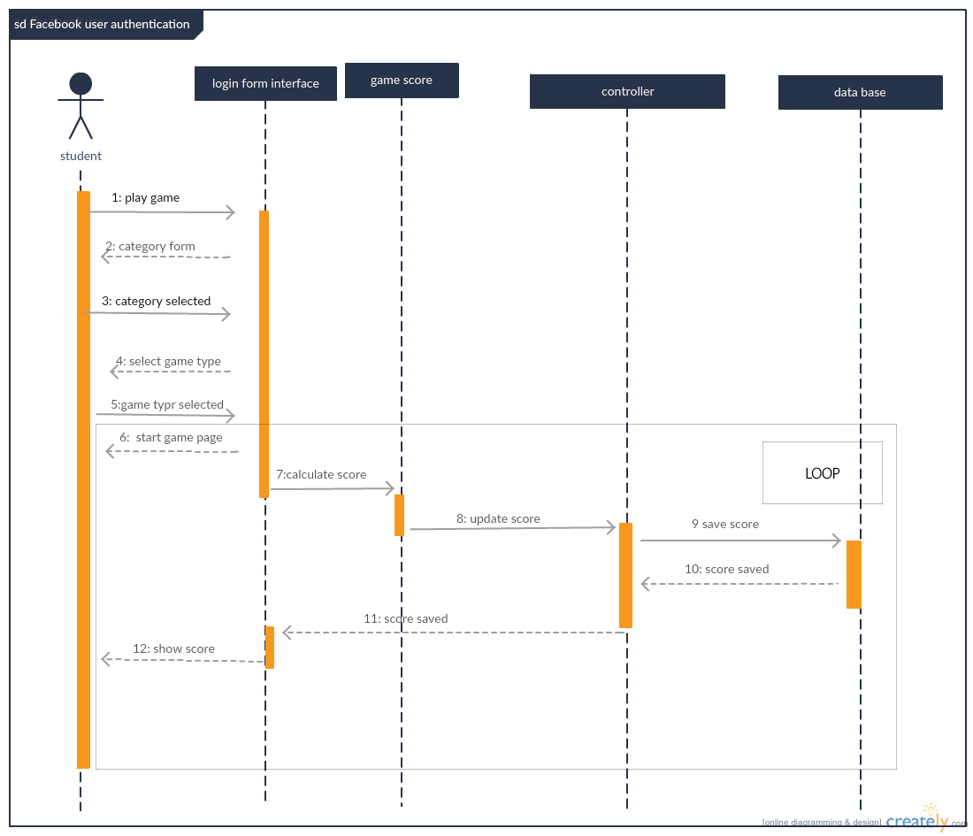

**3)**

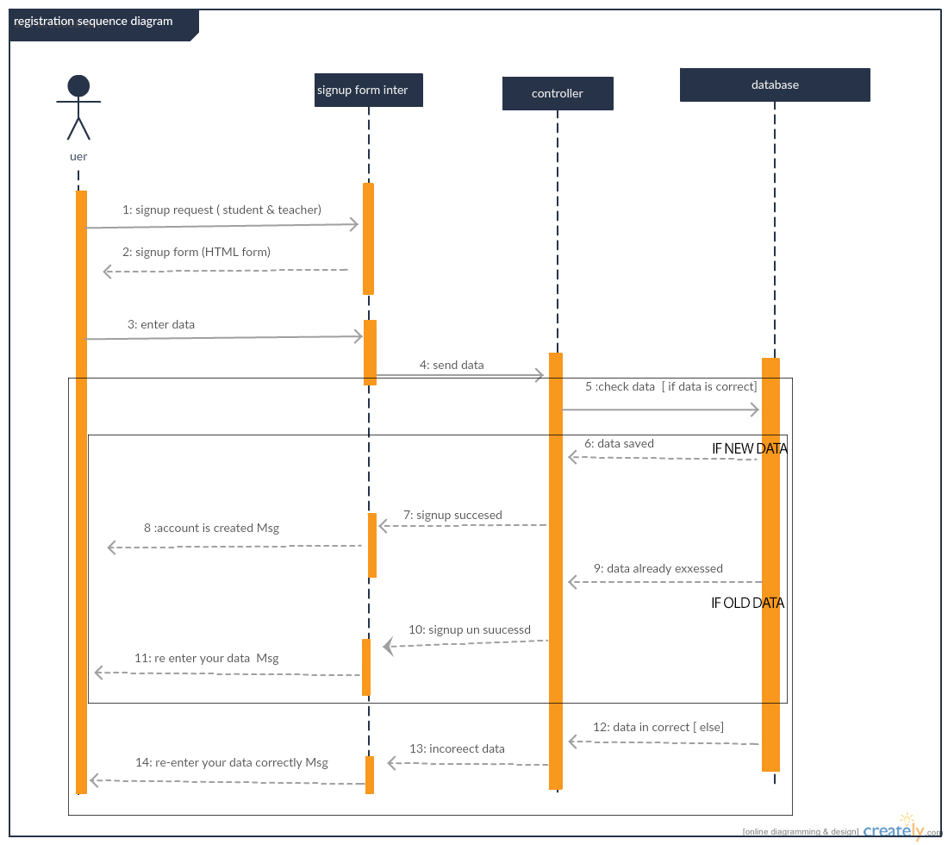

### 

### Class - Sequence Usage Table

| **Class Name** | **Sequence Diagrams** | **Overall used methods** |
| --- | --- | --- |
| Web Interface | 1 | Add game |
| Login form | 2 | Login |
| Sign up form | 3 | Sign up |
| Category list |  |  |
| Game list |  |  |
| Start game |  |  |
| Game control | 1,2,3 | Save data , get data and check data |
| Category |  |  |
| Game | 2 | Update score , calculate score |
| User | 3 | Login , sign up |
| teacher | 1 | Add game |
| student | 2 | Play game |

# Git-hup link

[https://github.com/amrkamal123/SW_project](%20https:/github.com/amrkamal123/SW_project)